NEELEY DRESS REHEARSAL

October 26, 2026
Dress Rehearsal
Audit and fixes
  - Security review of the student web app and its cloud services
The audit found practical ways to tighten request limits, private uploads, document parsing and browser behavior. The fixes strengthen the Neeley pilot while preserving the existing presentation workflow. This report records what was checked, what changed, and what still needs attention.
Review scope. The public GitHub Pages app, repository history and releases, Supabase authentication and data access, cloud speech processing, AI coaching, and browser inputs were reviewed. This is an engineering audit, not an independent penetration-test certification.
No exposed secret API credentials or unauthorized write access were found in the reviewed surfaces. This finding is limited to the checks recorded here.

Evidence at a glance
Area | Evidence examined | Observed result
Published source | 16 commits and 289 repository blobs | No secret credentials found in the scanned snapshot
Public deliverables | 9 live assets and 4 release ZIP files | No secret credentials found in the scanned artifacts
Public web surface | 25 bounded probes | Private-path checks returned 404; writes returned 405. One encoded-traversal request returned 503 and was inconclusive.
Cloud access rules | 11 deployed checks | Expected access-control responses verified; no paid inference used

Verification status. The fixes are saved locally and deployed to Supabase and GitHub Pages. Security release 24b8f3c is live. The cloud gateway also includes the follow-up two-operation memory guard. Eleven bounded live access checks passed.
The absence of a finding in these checks does not establish that every vulnerability is absent. The remaining risks and launch actions are recorded on the final page.

02 AUDIT FINDINGS

System components and trust boundaries
The browser captures and prepares the student’s material. Authenticated requests cross into the cloud gateway, where ownership, input limits and compute admission are enforced before private storage or model work.
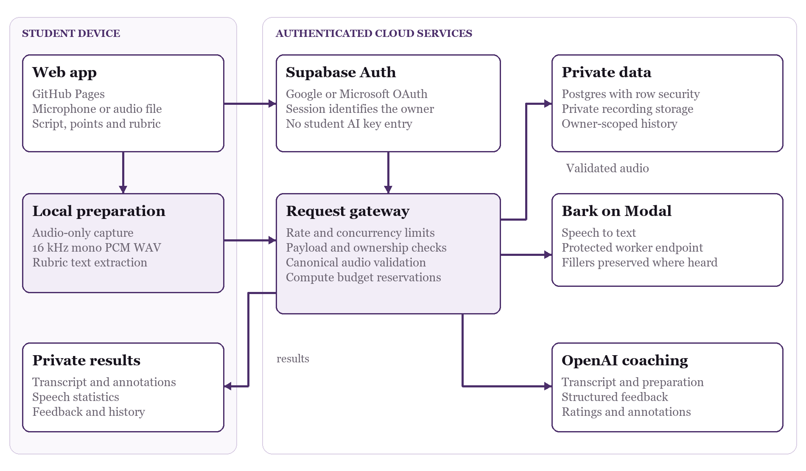
Figure 1 Student data crosses explicit boundaries between the device, the authenticated gateway, private storage and protected model services.

What leaves the device
Signed-in cloud rehearsals send audio segments for speech recognition and save the completed recording privately. Coaching receives the transcript and preparation text, including extracted rubric text. Raw rubric documents stay on the device. Browser playback does not rerun the models. Opt-in usage events contain activity identifiers and timing rather than transcript text.
Service credentials belong in server configuration. Students use the account sign-in flow and do not enter a provider API key. Google and Microsoft are the supported sign-in integrations; provider availability still depends on each integration’s configuration.

03 AUDIT FINDINGS

Request controls and spending exposure
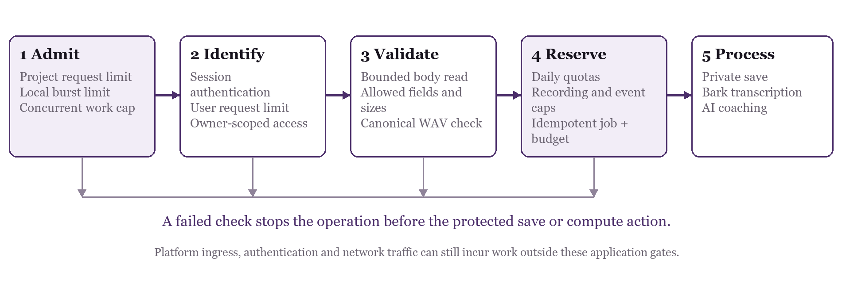
Figure 2 Rejected requests stop at the relevant admission or validation check. The platform still handles incoming network traffic.
Control | Configured limit or behavior
Distributed HTTP limits | 1,200 requests per minute per project; 120 per minute per user
Local request guard | 60-request burst; 10 per second; 8 simultaneous requests per isolate. Whole-audio upload, batch transcription and live completion share a tighter 2-operation cap.
Request body | 20-second read deadline plus route-specific size and shape validation
Recording admission | 40 per user per day; 400 globally per day; 10,000 retained metadata rows
Usage events | 1,000 per user per day; 10,000 globally per day; 100,000 retained events
Abandoned reservations | One-hour lease; expired metadata is retained and saved audio is not deleted

Compute protection. Idempotent job IDs prevent repeated submissions from starting the same paid job twice. Admission reserves estimated work against the configured $5 daily AI ledger. Reservations are accounting controls, not the provider’s invoice or an absolute billing guarantee.
The complete serialized coaching prompt is capped at 256 KiB to constrain long-context requests. The $0.06 coaching reservation is an estimate. Modal remains configured with $30 of included usage and a $0 paid-spend guard. Provider billing settings and actual invoices still need review.

04 AUDIT FINDINGS

Private data and hostile input handling

Authentication and database access
The audit reviewed row-level security and privileged database-function access. After deployment, checks confirmed no browser storage INSERT policies, an active upload guard, and no browser permission to execute the rate-limit function. Ownership comes from the authenticated session. User-supplied text is treated as data, and SQL-shaped strings were exercised in rollback tests so the test changes did not persist.
Private audio now enters through a validating gateway. The browser’s direct storage INSERT permission is revoked. The gateway accepts only the supported canonical audio structure before using privileged storage access. Canonical PCM validation verifies the format, not that samples contain only human speech; arbitrary information encoded in sample values cannot be excluded. Private history and signed playback links remain scoped to their owner.

Audio capture and file preparation
Microphone requests explicitly set video to false. Uploaded recordings are decoded and converted to a new 16 kHz mono PCM16 WAV; the original file and embedded metadata are not forwarded. A short metadata check rejects known recordings over ten minutes before full decoding. Unknown or infinite-duration WebM files retain the existing decoder fallback.
Residual resource risk. Browser audio decoding has no reliable hard allocation limit or cancellation API. Missing or misleading duration metadata can still force expensive native decoding within the existing file-size limit. The gateway’s two-operation whole-audio cap reduces concurrent large buffers but is not a hard memory guarantee.

Rubrics and rendered text
Rubrics are limited to 5 MB and 40,000 text characters. PDFs allow at most 30 pages and use an explicitly owned native worker with a 30-second read timeout. Failure terminates the worker directly; main-thread fallback is disabled. Word documents cap inflated XML at 2 MB, ZIP entries at 1,024 and nesting at 128 levels. External relationships and traversal paths are ignored; XML entity declarations are rejected.
Transcripts, model feedback, rubric names and saved titles render as text. Exported transcript HTML escapes content and restricts its own document policy. Prototype-shaped JSON keys and SQL quotes or comments remain inert data in the tested paths.
Storage size. Five minutes of current WAV audio uses about 9.6 MB. At fixed rates, MP3 at 64 kbit/s would use about 2.4 MB and Opus at 32 kbit/s about 1.2 MB. The microphone captures samples; WAV is the app’s encoding choice. A compressed private archive is a future option, not a change made in this audit.

05 AUDIT FINDINGS

Fixes and supporting checks
Finding or exposure | Change made and evidence
Repeated requests and accidental duplicate actions | Added distributed request limits and local concurrency protection. Existing job idempotence and spending reservations protect paid operations. Browser history refreshes now coalesce; sign-out has an in-flight lock.
Unvalidated direct audio storage | Removed direct browser storage INSERT and routed new audio through canonical WAV validation before private storage. Ownership and bounded request handling remain required.
Abandoned reservations and metadata growth | Added expiry handling and admission caps for recording metadata and opt-in usage events. Expiry preserves saved audio and retains metadata. Retention caps do not automatically purge data.
PDF parser cleanup could hang | Introduced an owned native worker and immediate termination on timeout or failure. Controlled tests cover hanging cleanup and worker failures. A production-browser PDF rubric import extracted all fixture criteria without console warnings or errors.
Large audio files could decode before duration rejection | Added a 1.5-second metadata preflight with object-URL cleanup and account-change cancellation. Known overlong files stop before a full file read or native PCM decode; unknown metadata follows existing validation.
Browser and build hardening | Added Content Security Policy and referrer controls to the build, secret-detection checks, and pinned CI action references. The published page was verified to include the enforcing policy and no-referrer setting.
Development dependency advisory | Updated body-parser from 2.3 to 2.4 in the development dependency tree. This was not a vulnerability in the static live web app’s runtime. The final package audit reported no known vulnerabilities at any severity.

Duplicate action stress tests
Bursts of 1,000 Analyze, transcript, Record, Stop, history, sign-in and sign-out callbacks were tested without real AI calls. The protected actions shared in-flight work instead of duplicating it. These browser locks improve behavior; server enforcement remains necessary because a caller can bypass the UI.
A separate local limiter harness exercised 10,000 simulated attempts. The audit used bounded probes and controlled test fixtures, not a real traffic flood. These checks measure defined enforcement behavior, not platform-wide denial-of-service resistance.

06 AUDIT FINDINGS

Verification record and remaining actions
Verification layer | Result and scope
Browser input and account tests | 121 focused browser and account tests passed at the checkpoint; included within the Node suite
Application regression suite | 452 of 452 Node tests and 19 of 19 Python worker tests passed; production build passed
Database checks | 92 linked SQL assertions passed with rollback: 55 security checks and 37 pilot regression checks
Backend access checks | Eleven post-deployment live checks passed, covering private routes, fake sessions, origins, method handling, storage and the protected speech endpoint. No paid inference was used.
Public surface and packaging | 25 public probes; 16 commits, 289 blobs, 9 live assets and 4 release ZIP files scanned
Release verification | GitHub Pages release 24b8f3c deployed successfully. The live page returned HTTP 200 with enforcing Content Security Policy and no-referrer settings. The production sign-in UI initialized without console errors. The latest gateway memory guard is deployed.

Actions before a broader pilot
Rotate previously shared keys. Credentials pasted into chat should be replaced before wider access. No key values are included in this report.
Review platform controls. Edge function limits do not cover every Supabase Auth, storage delivery, network ingress or provider operation. Platform denial-of-service and egress exposure remain outside these tests.
Strengthen framing protection. GitHub Pages cannot supply a custom response frame-ancestors policy through the current static deployment. A host or proxy that controls response headers would allow stronger anti-framing protection.
Keep budget oversight. Confirm provider billing limits, monitor real invoices and review reservation amounts as model choices or usage change.
Test a wider device range. Older phones and computers still have resource constraints. Browser decode risk and device-specific behavior require continued testing.
Commission independent review. A professional security assessment remains appropriate before broader institutional deployment. This audit is not a certification or a guarantee against compromise.
Evidence handling. Test fixtures were isolated, database assertions used rollback, and the report excludes student content, credentials and private infrastructure identifiers. Final release evidence should be tied to the deployed commit recorded above.

